­­



|  |
| --- |
| **MATHEMATICS DEPARTMENT**  **Year 12 Methods - Test Number 5 - 2017  Sample Proportions & Confidence Intervals  Resource Rich** |

**Name: _______________________________________ Teacher: __________________**

**Marks: 50**

**Time Allowed: 45 minutes**

**Instructions:** You are allowed Calculators BUT no notes.

You will be supplied with the WACE Examination formula sheet. ______________________________________________________________________

1. [6 marks]

It is known that 65% of a community is in favour of building a new road to reduce congestion on existing roads.

With A and B placed the same distance either side of the 35% population proportion find the values of A and B to the second decimal place that will complete the following statement correctly:

*“There is a 90% chance that in a sample of 400 people from this community, the sample proportion against the building of the new road will be between A% and B%.”*

1. [2,3,2,3 = 10 marks]

The length of phone calls at a call centre is uniformly distributed over the interval 10 to 30 minutes.

1. Find the probability that the length of phone call for any caller is no more than 15 minutes.

In a study of phone call length, the lengths of calls for samples of 50 different callers each, were recorded.

1. Describe the sampling distribution of the proportion of callers with lengths of phone calls being no more than 15 minutes.
2. Find the probability that a randomly chosen sample has a sample proportion of callers with phone calls lasting no more than 15 minutes that exceeds 0.31.
3. 40 samples each containing 50 callers were chosen. Determine with reasons, the expected number of samples with sample proportions of callers waiting no more than 15 minutes that exceeds 0.31.

3) [4 marks]

Following the release of the latest Federal budget, the Australian public was invited to ‘twitter’ their favourable or non-favourable responses. Identify and comment on this method of sampling for gauging the proportion of the Australian public that found the budget favourable and identify and discuss possible sources of bias.

1. [4 marks]
   1. If the proportion population, p, is 0.5, the sample size 400, determine the proportion of successes in the sample that lie between 0.43 and 0.51.
   2. What happens if the sample size is reduced to 150?
2. [1,2,2 = 5 marks]

Consider the Bernoulli variable X with probability of success *p* and the same probability of failure. One sample containing 45 observations of X was obtained and these results are displayed below:

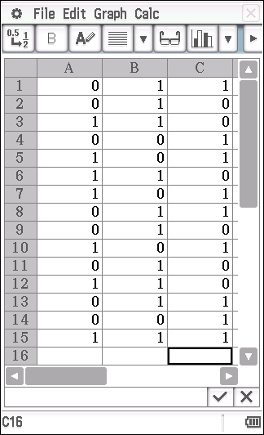

Note : 1 = success ; 0 = failure

a) What is the point estimate for the number of successes *p*?

1. Describe the probability distribution for the statistic 
2. What is the probability that the next sample of 45 will have a sample proportion greater than 0.55?
3. [5,3 = 8 marks]

A survey of 950 drivers asks if they thing that the penalties in WA for driving 15km above the posted limit are too severe. 309 of the 950 drivers do think the penalties are too severe.

* 1. Find the 95% confidence interval for the population proportion and interpret your answer.
  2. Compare your result above to the situation where only an 80% confidence is required and write a sentence that explains the difference.

1. [3,2,4,4 = 13 marks]

A survey conducted in Perth asked respondents to indicate whether they had stayed in a 5-star hotel in the last 12 months. Out of 2540 people, the survey found that 1220 indicated they had stayed in a 5-star hotel in the last 12 months.

* 1. Determine a 90% confidence interval for the proportion of people in Perth who have stayed in a 5-star hotel in the past 12 months. What assumption was made in calculating this interval?
  2. Determine the margin of error in this confidence interval.

Another three surveys of people across Australia were conducted asking the same question and the results of these surveys are shown in the table below.

|  |  |  |
| --- | --- | --- |
| Survey 2 | Survey 3 | Survey 4 |
| Stayed in 5-star hotel in past 12 months | Stayed in 5-star hotel in past 12 months | Stayed in 5-star hotel in past 12 months |
| 2001 out of 3999 people | 423 out 1222 people | 2976 out of 6222 people |

* 1. Determine which of these surveys were more likely to have also been taken in Perth. Justify your answer(s).
  2. Using the sample proportion of the survey at the start of the question, determine a sample size that will halve the margin of error for the proportion of Perth people who have stayed in a 5-star hotel in the past 12 months with a confidence of 90%.

**End of Test**